**VS Code Extension for Icon Theme Color**

**00. Material Icon Theme:**

Details is coming soon.

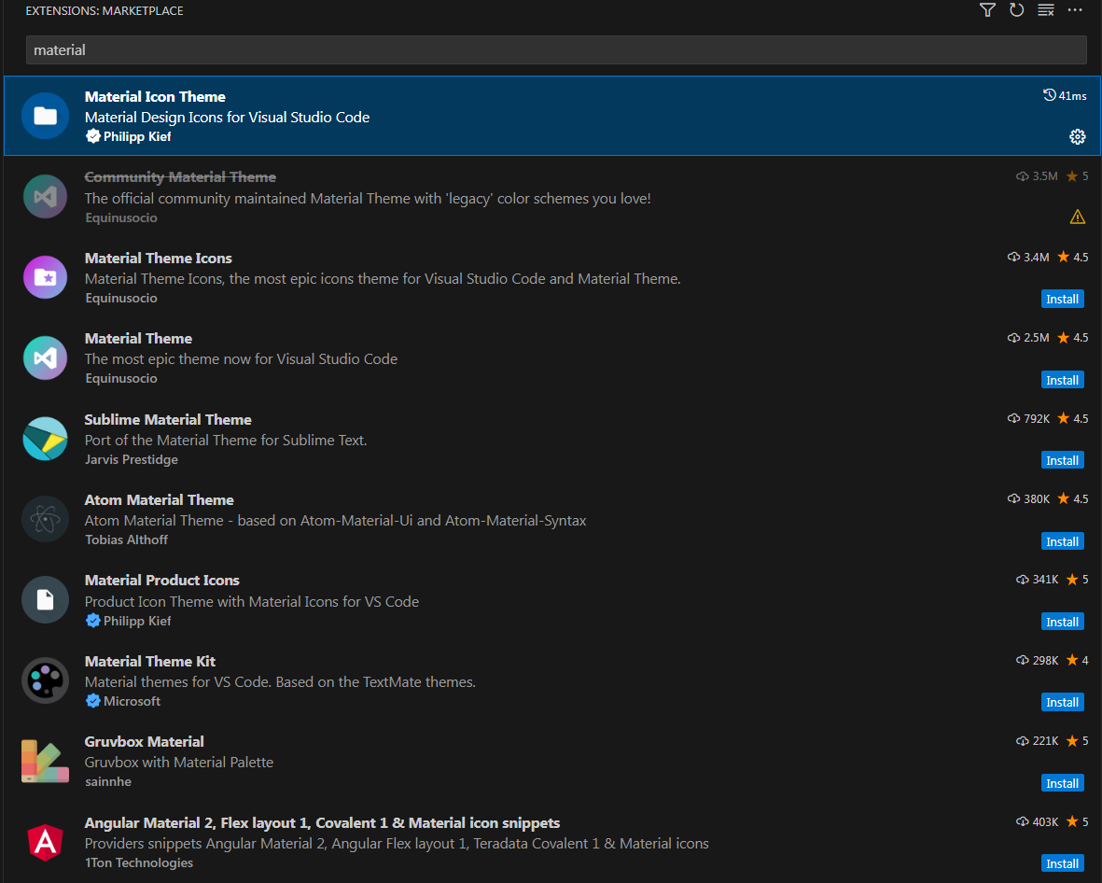

**VS Code Extension For HTML**

1. **Live Server:** This extension provides a live preview of your web pages in real-time as you edit them. It's especially useful for front-end development, allowing you to see changes instantly in the browser.

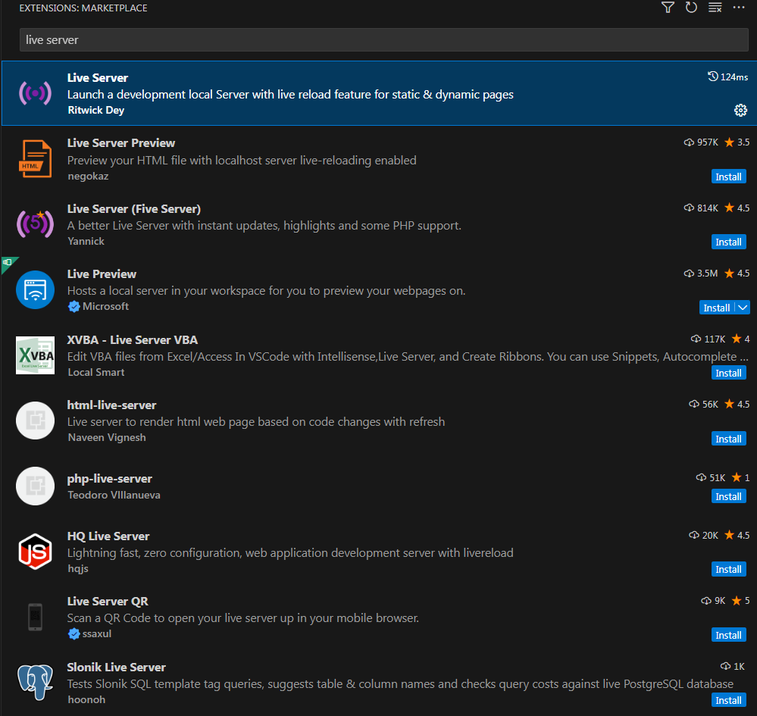

1. **HTML End Tag Labels**: This extension adds labels to closing HTML tags. It's particularly helpful in large HTML files to quickly identify which closing tag corresponds to which opening tag, improving code readability.

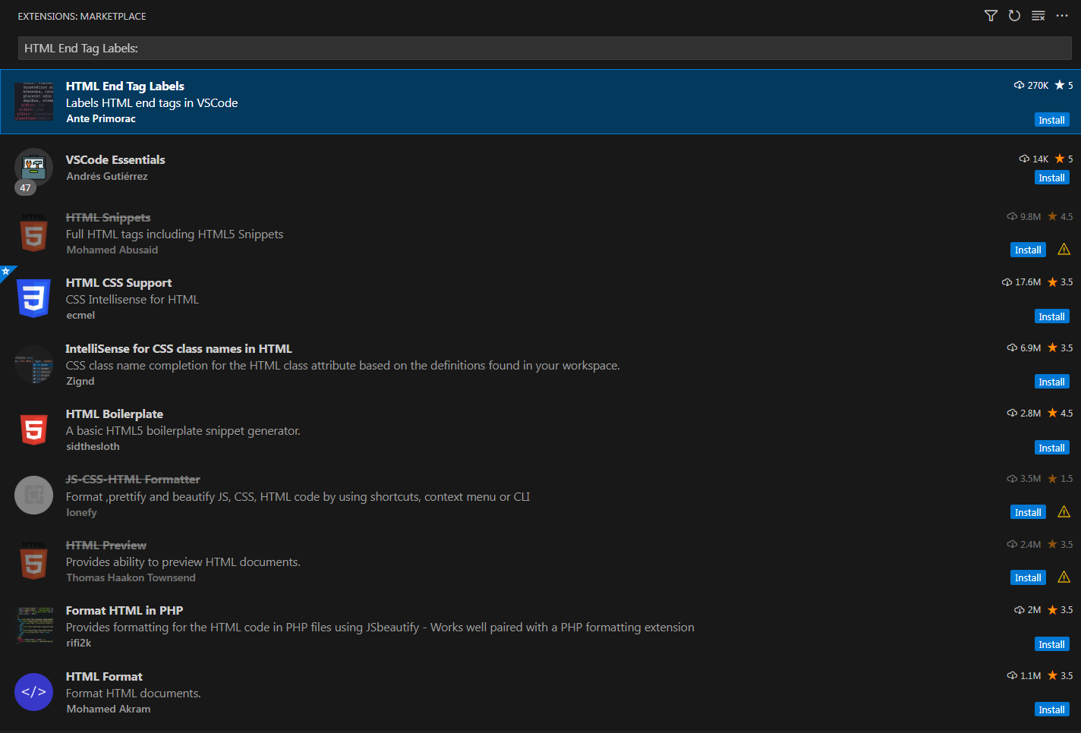

1. **Auto Close Tag**: Automatically adds HTML/XML close tags as soon as you type the opening tag. It speeds up your HTML coding by reducing the amount of typing required.

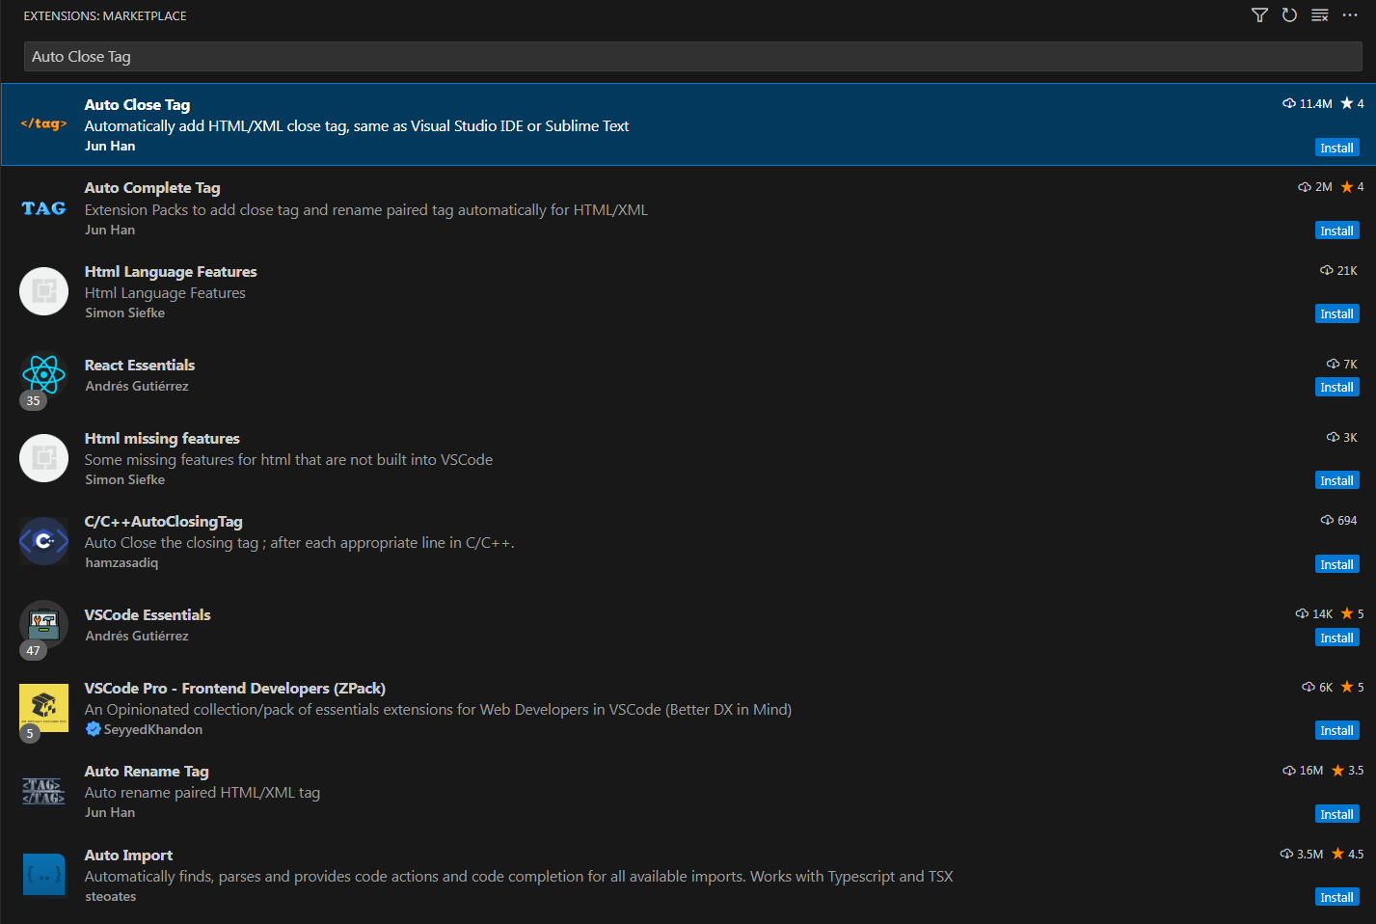

1. **Highlight Matching Tag:** Whenever you select an HTML tag, this extension highlights the matching opening or closing tag. This feature is useful for quickly navigating and understanding the structure of your HTML code.

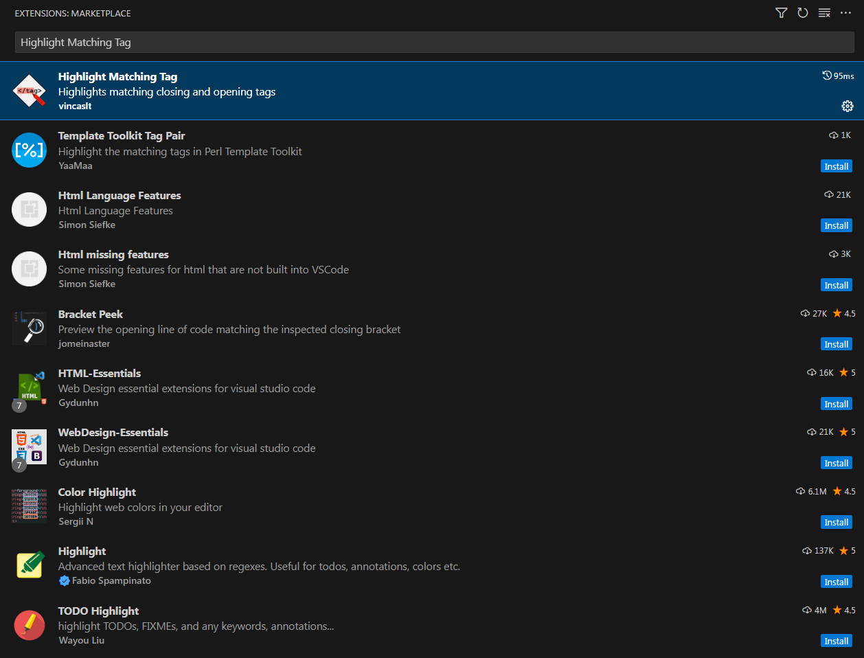

1. **Auto Rename Tag:** When you rename one HTML/XML tag, this extension automatically renames the matching paired tag. It's a great time-saver and helps prevent errors in tag renaming.

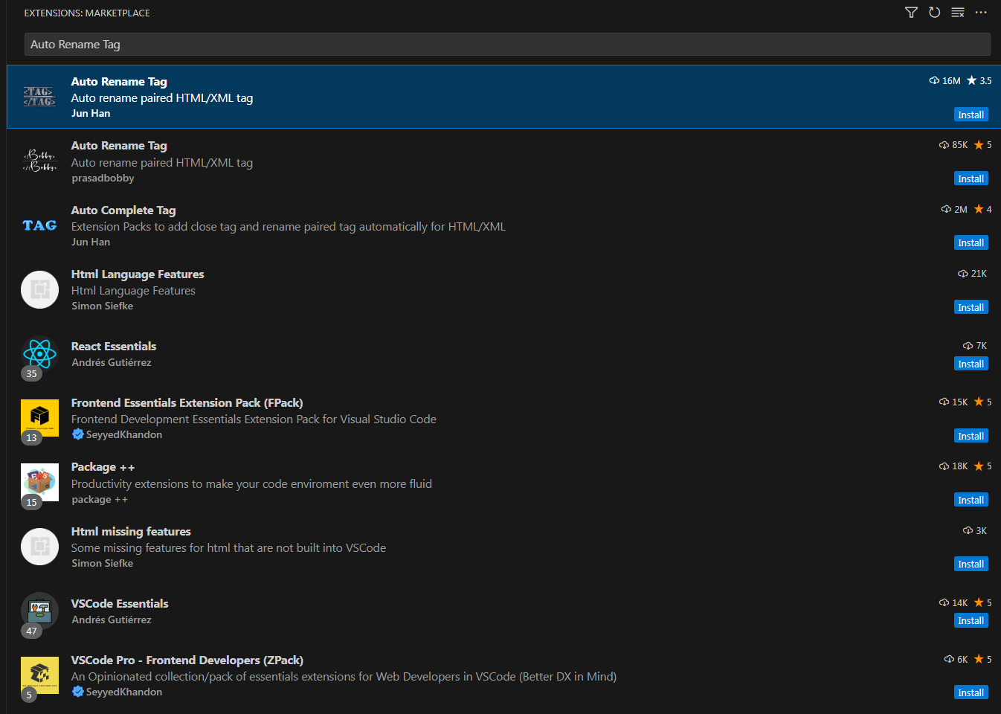

1. **Code Spell Checker:** This extension helps to catch common spelling errors in your code. It supports multiple languages and programming languages, making it an essential tool for maintaining professional and error-free code.

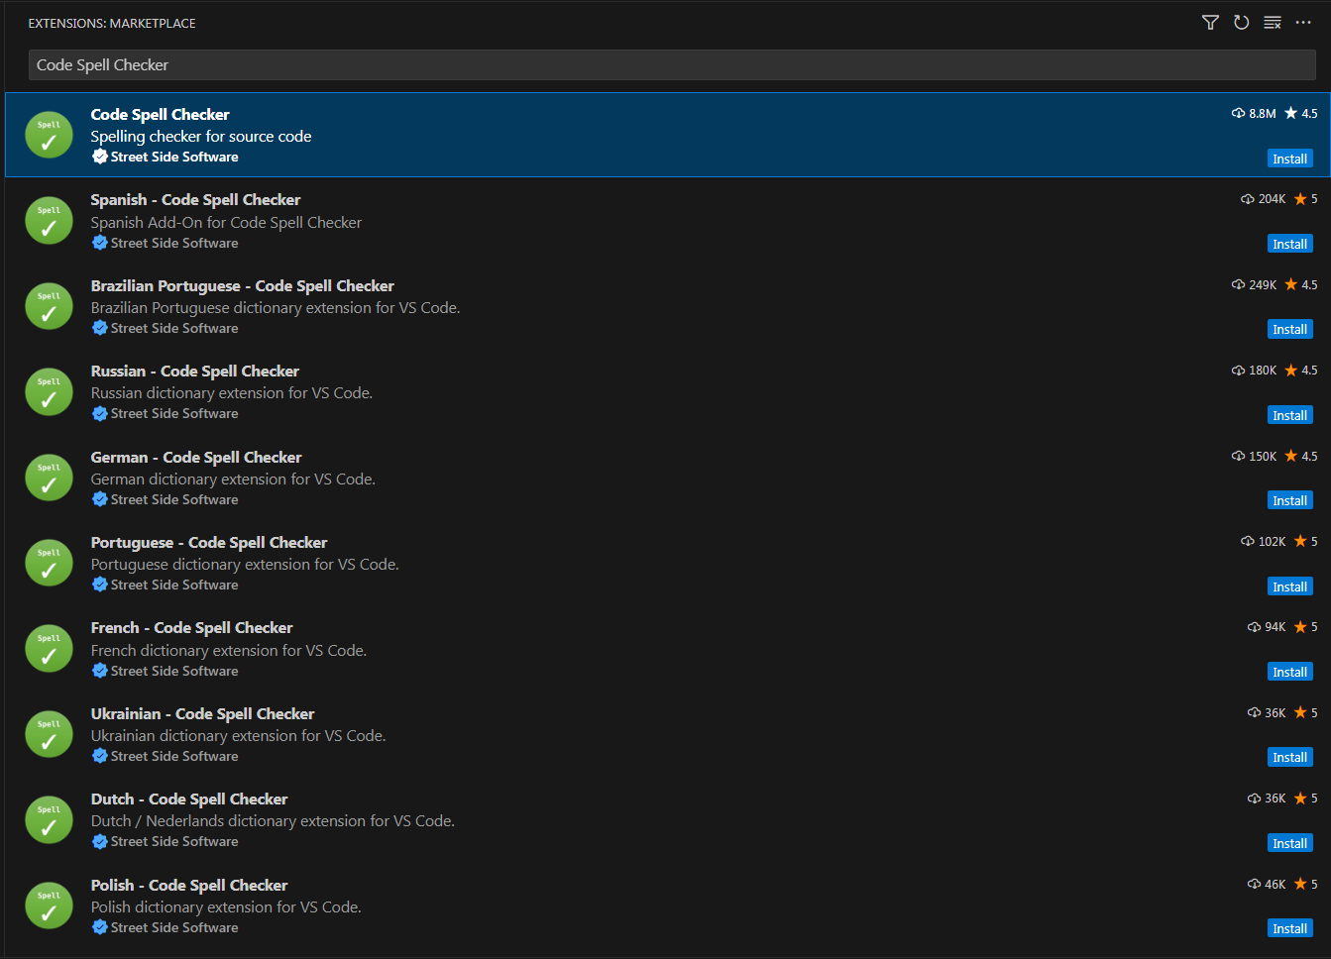

1. **Indent Rainbow:** This extension colorizes the indentation in front of your text, alternating four different colors on each step. It's visually appealing and makes it easier to distinguish different levels of indentation at a glance.

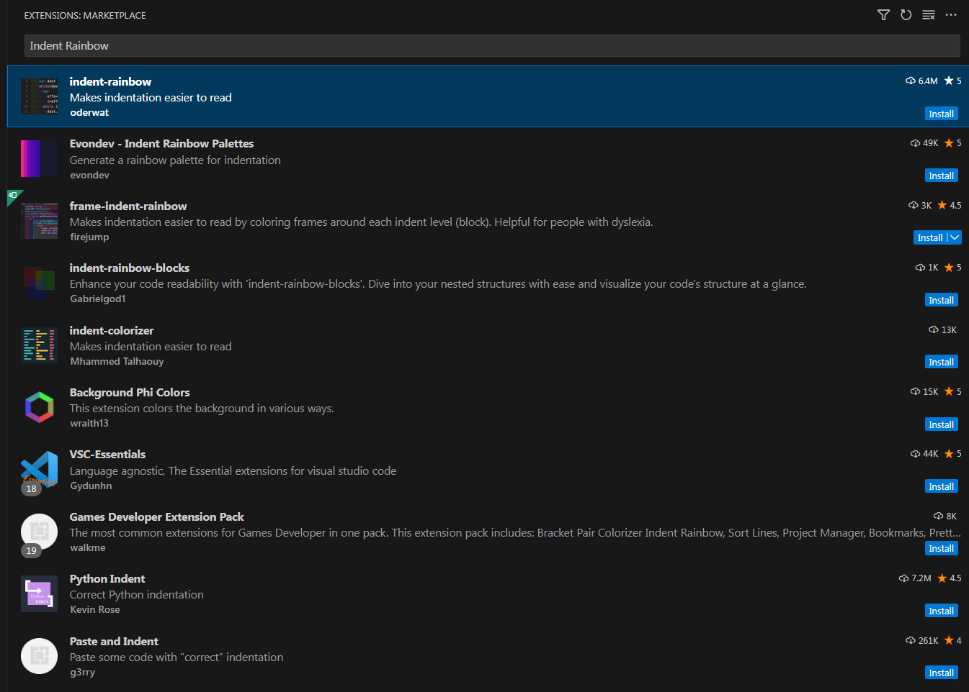

1. **Prettier - Code Formatter:** Prettier is a popular code formatter that supports many languages and integrates with most editors. It formats your code consistently, following a set of rules, which improves readability and reduces the chance of syntax errors.

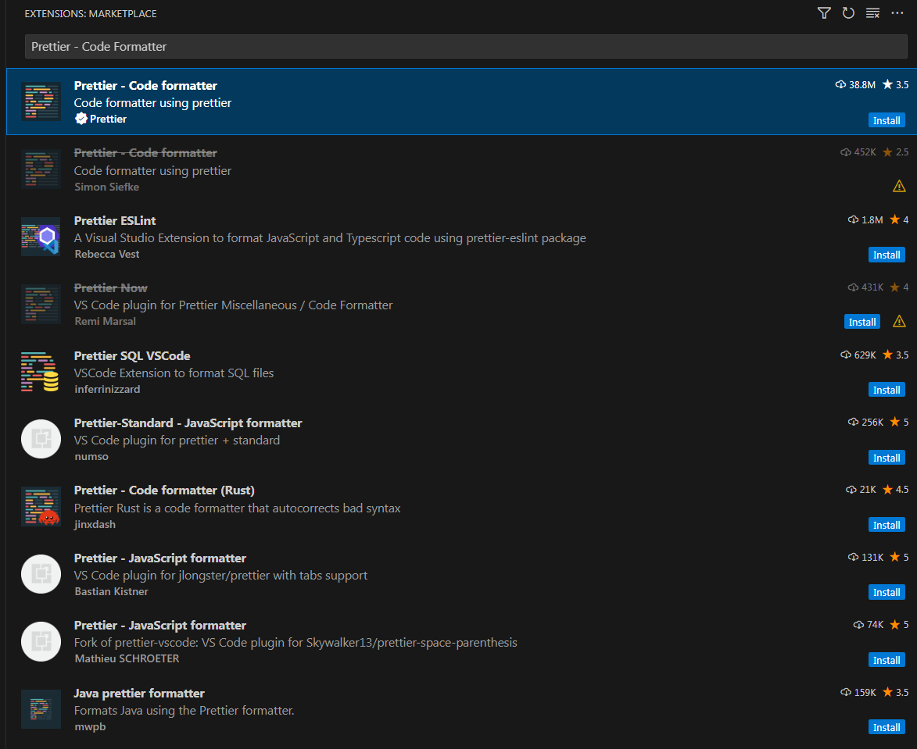

1. **Axe Accessibility Linter:** This extension is focused on web accessibility, providing automated testing of HTML for accessibility issues. It's a vital tool for ensuring that web content is accessible to all users, including those with disabilities.

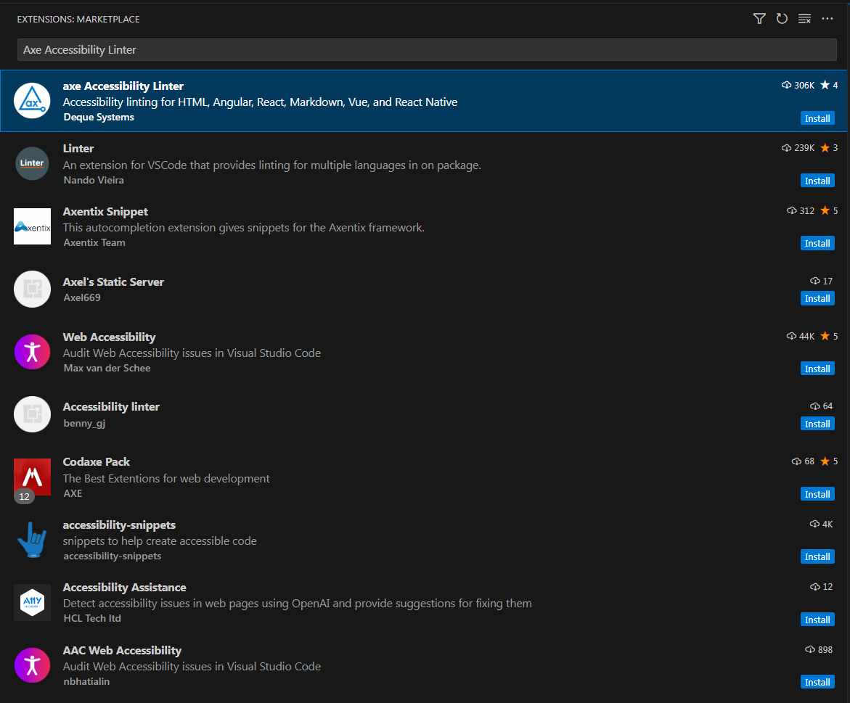

**VS Code Extension For CSS**

1. **CSS Peek**Details will coming soon.  
     
   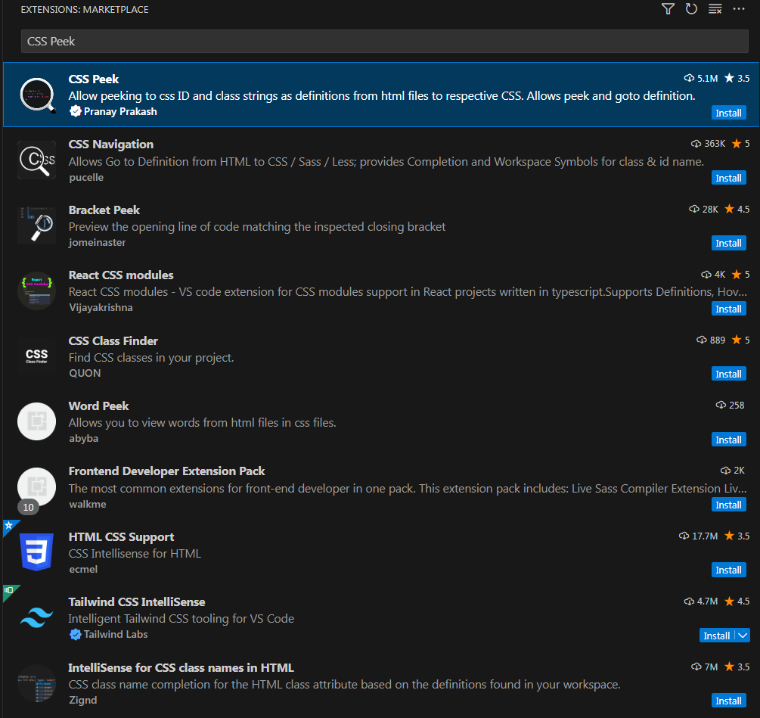
2. **HTML C SS Support**Details will coming soon.

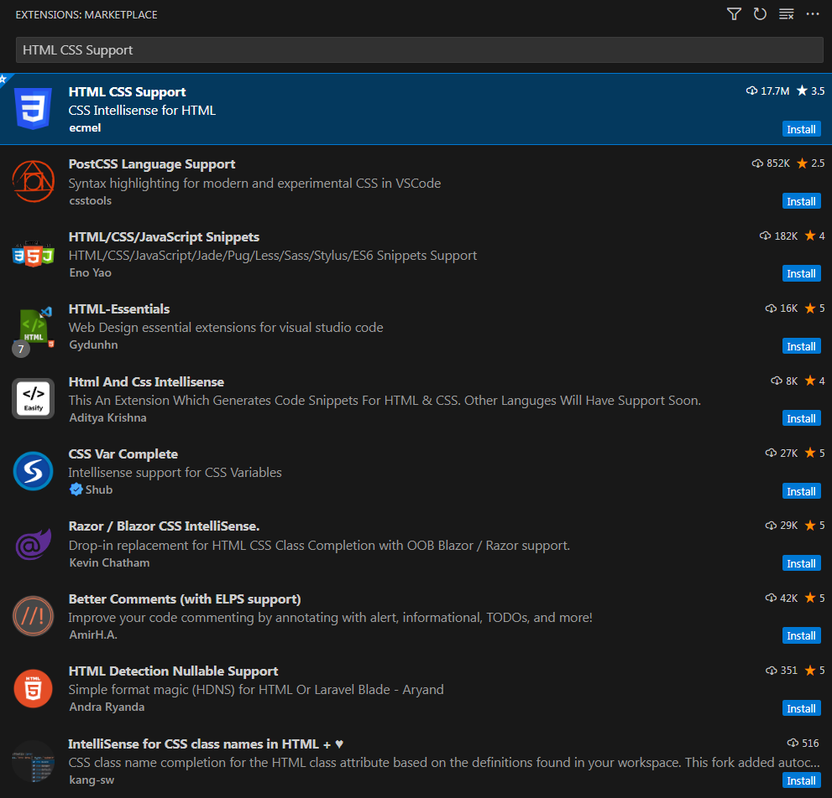

1. **Color Highlight**

Details will coming soon.

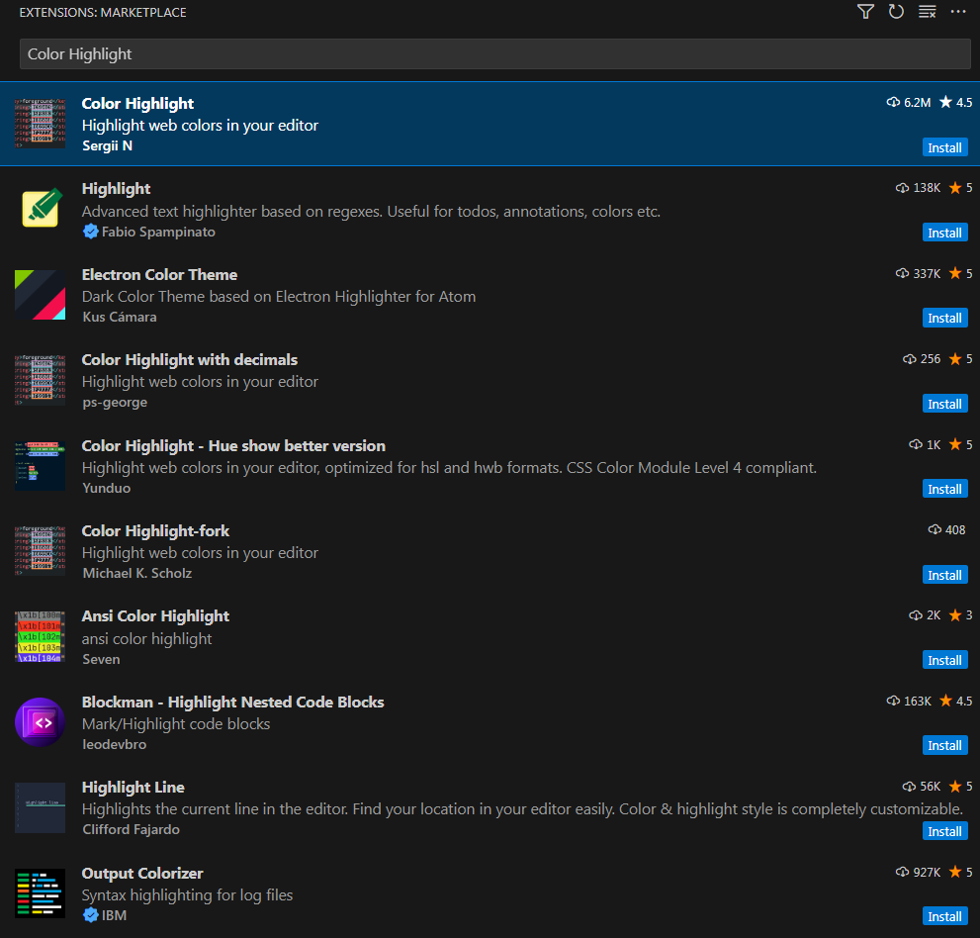

1. **IntelliSens for CSS class names in HTML**

Details is coming soon.

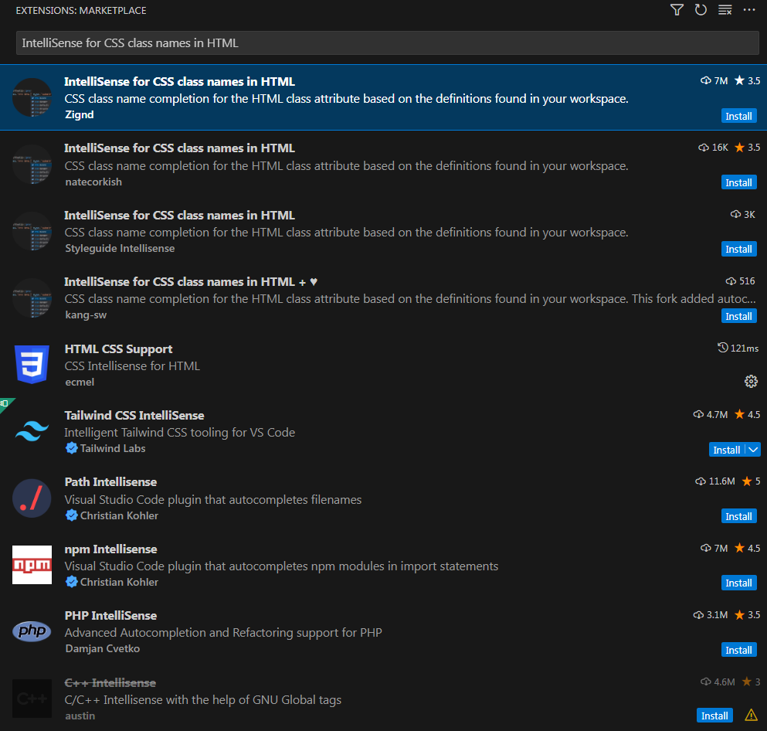

1. **Autoprefixer**

Details will Coming soon.

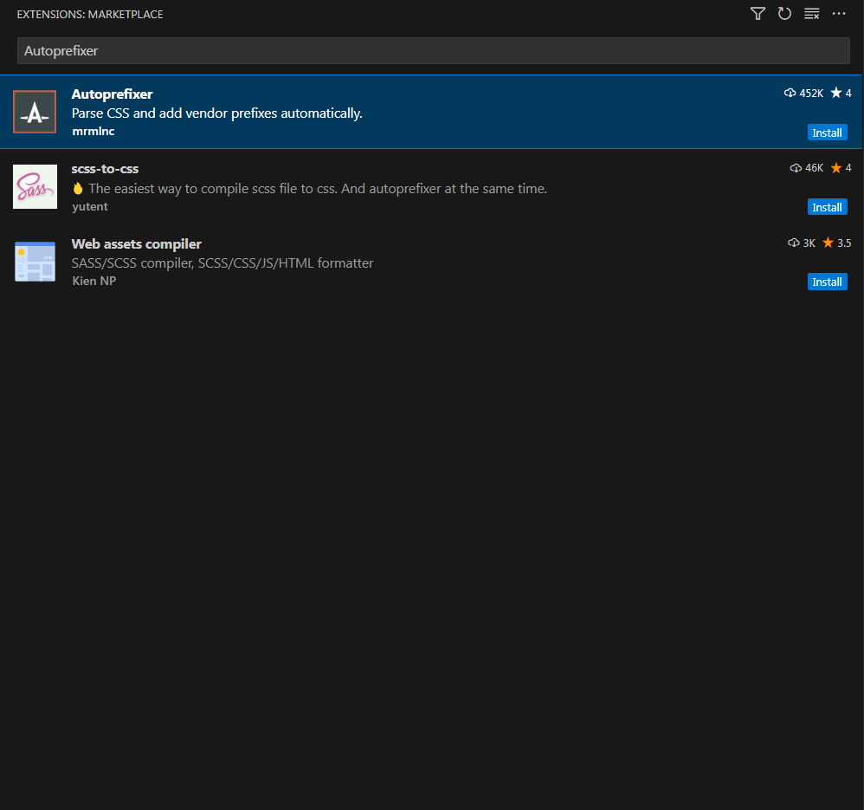

1. **CSS-Auto_Prefix**

Details will coming soon.

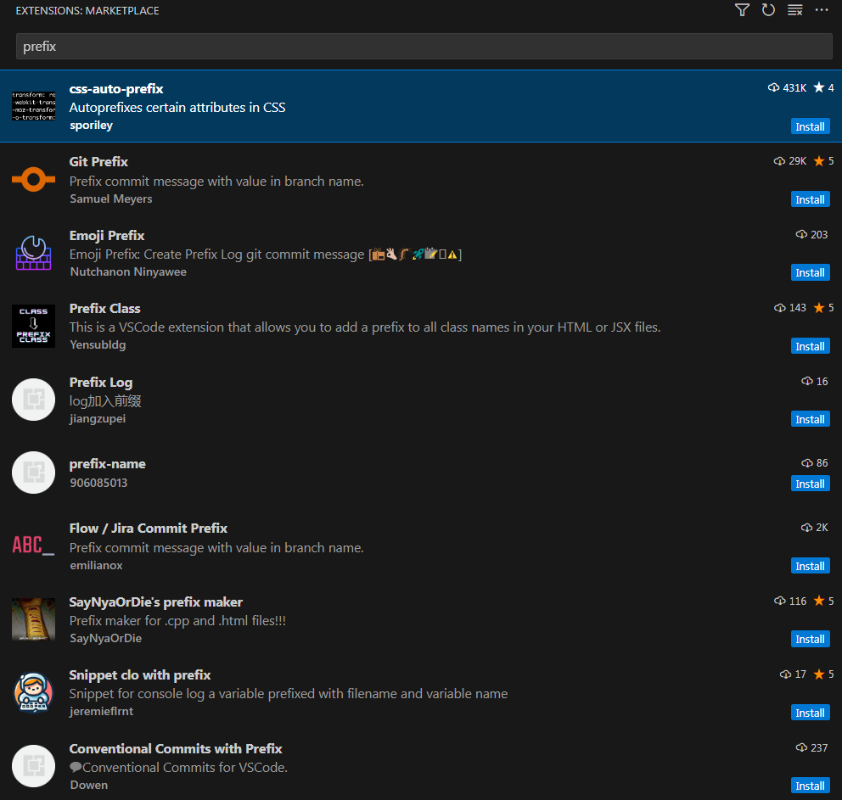

1. **Stylelint**

Details is coming soon.

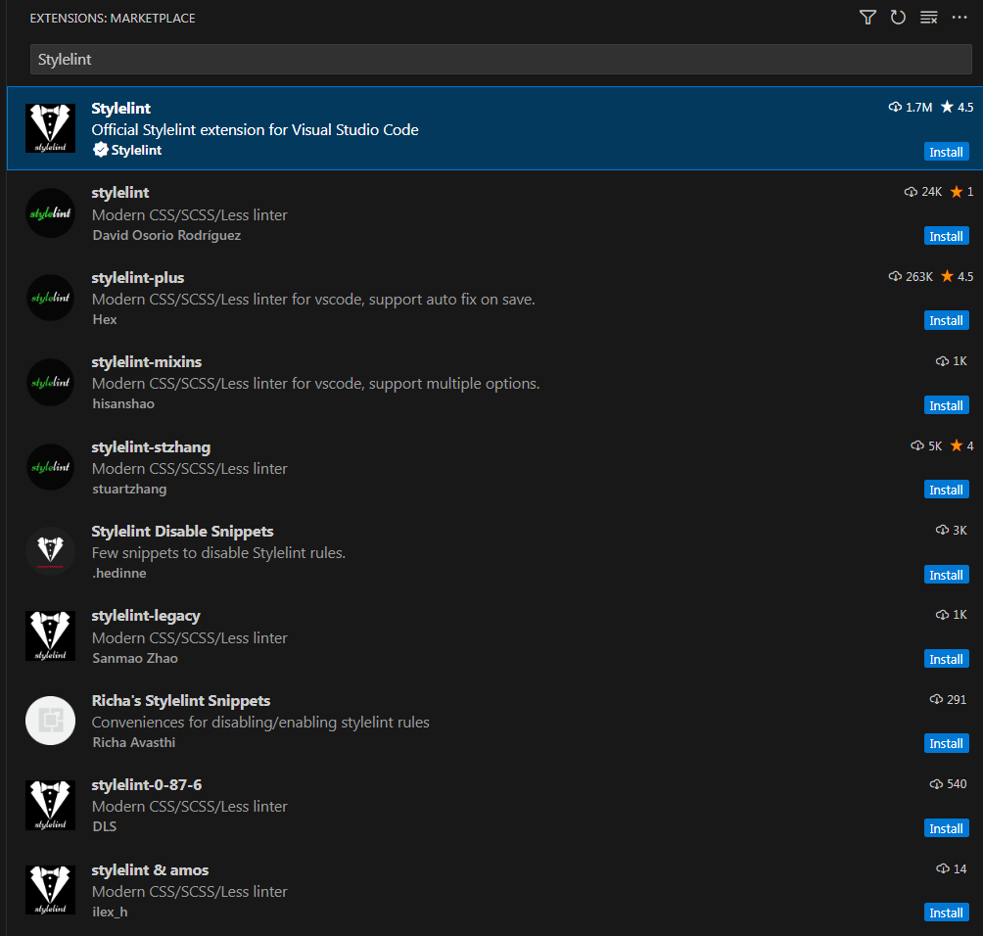

1. **Hlkjhlkjh**

Details is coming soon.

1. **Kkjhgjhg**
2. **Kjhkjhkj**
3. **kjhlkj**